**Hands On Guide for Cloud Storage**

* Hit the NFE URL <https://internal.netforumcloud.org/NFEP2017/iWeb/> (Replace URL with the correct one)
* Enter provided Username and Password.
* Click Sign In.

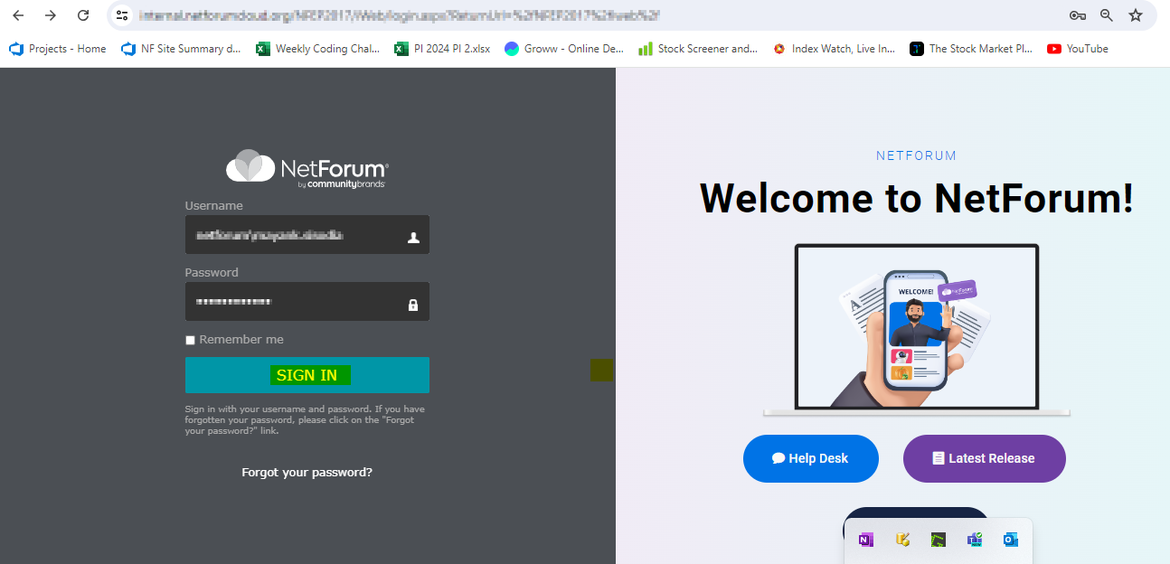

* Once successfully logged in, from the left corner Select CRM module, Individual and Query Individual
* Now, type *First* in “Column To Query” Section and select “Individual: First Name”  
    
  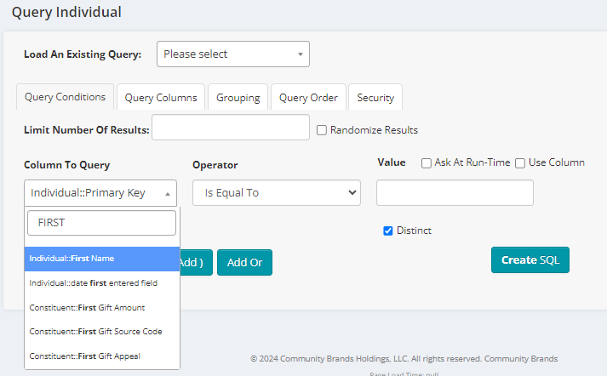
* Select *Contains* in “Operator” section and type *A* in Value section.
* Click “Add To Query” button.  
    
  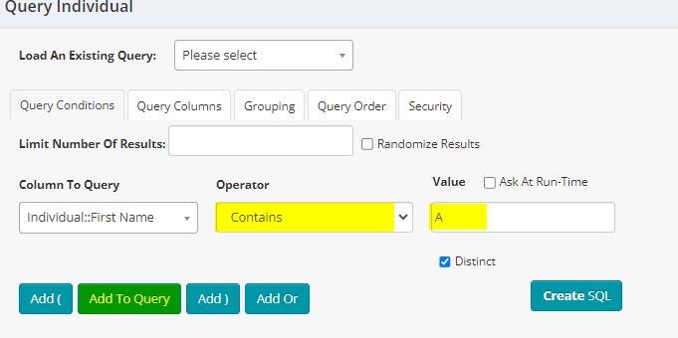
* In “Query Name” section type the unique name of the query e.g. TestQuery
* Click “Save Query” button.  
    
  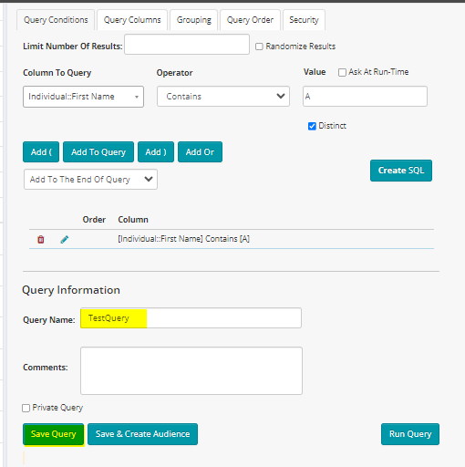
* Click “Run Query” button to make sure you are having some data in the query you just created.
* Now, from the left corner Select CRM module, Individual and Query Central  
    
  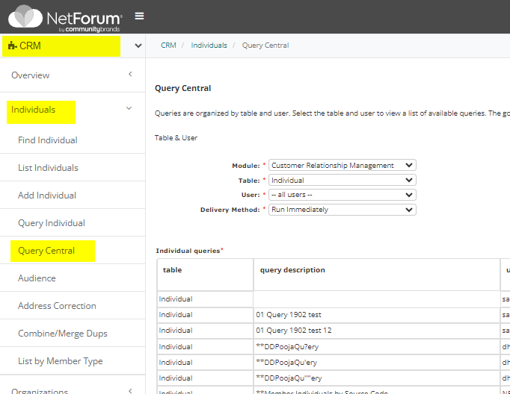
* Select below options from the Dropdown as shown in Screenshot

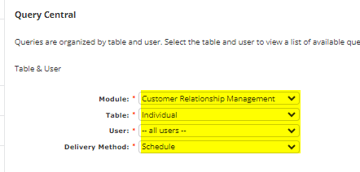

* Now select the Newly Created query from the below section, click “go”.  
    
  A screenshot of a computer

  Description automatically generated
* Click Go again on the next window and you will see below screen.

* Click Now and click Save.

* The task will be created in the “Scheduled” state   
    
  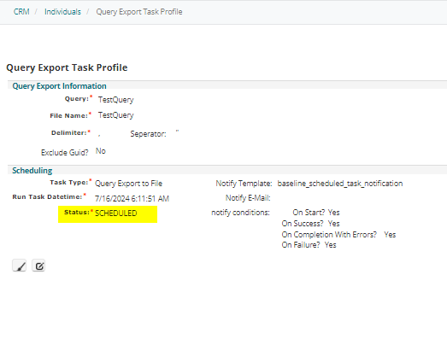
* Once the task is successfully completed. The status will change to “Success” and the details will be displayed in the history child form which will include the URL where the file is stored.  
    
  A yellow rectangular object with black text

  Description automatically generated
* Copy the URL and execute the same on Browser.
* You will see the output list.